NUCLEAR PAST EXAM BOOKLET

Contents

Syllabus Points 3

Properties of Alpha, Beta and Gamma – 3.3 4

2015 4

2018 4

2021 4

Half-life and Decay Series 3.4 5

2021 5

2015 6

2015 6

2016 7

2017 8

2022 8

2018 9

2019 11

2021 12

Radiation Doses and Effects on Humans 3.5 14

2017 14

2018 14

2022 15

2015 Comprehension 16

2016 Comprehension 20

2020 Comprehension 23

Nuclear Fission – 4.1 26

2018 26

2019 28

Nuclear Reactors 4.2 31

2021 31

Nuclear Fusion and Binding Energy 4.3 34

2015 34

2016 35

2017 37

2020 38

2020 39

2021 42

2021 45

2019 Comprehension 47

2022 52

# Syllabus Points

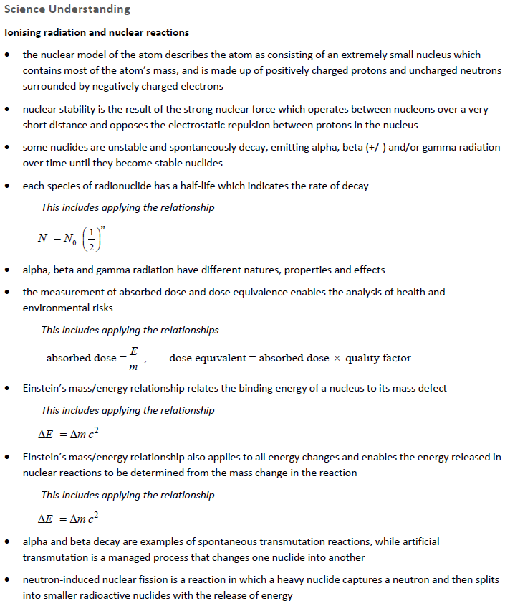

# Properties of Alpha, Beta and Gamma – 3.3

## 2015

## 2018

## 2021

# Half-life and Decay Series 3.4

## 2021

## 2015

## 2015

## 2016

## 2017

## 2022

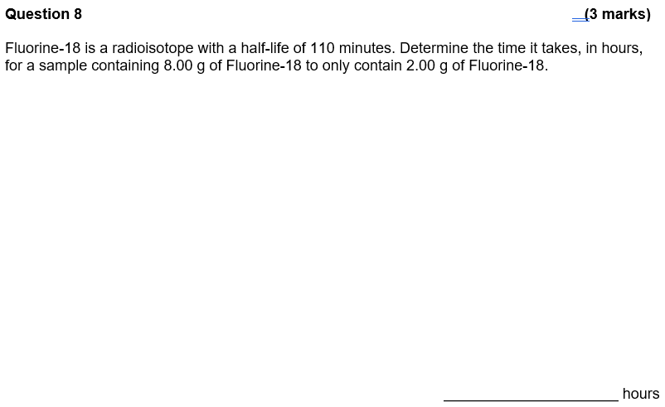

## 2018

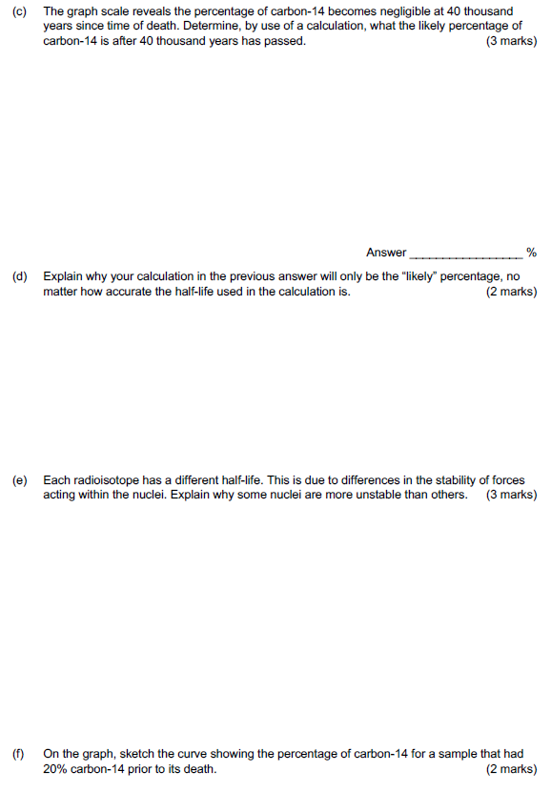

## 2019

## 2021

**Question 13 (14 marks)**

The radioisotope most widely used in medicine is an isotope of Technetium, Tc-99. It is employed in some 80% of all nuclear medicine procedures. Tc-99 has almost the ideal characteristics for a nuclear medicine scan. These are:

* It has a half-life of 6 hours.
* It mainly emits gamma rays.
* The chemistry of technetium is so versatile it can form tracers by being incorporated into a range of biologically-active substances that ensure it concentrates in the tissue or organ of interest.

Its logistics also favour its use. Technetium generators – a lead pot enclosing a glass tube containing the radioisotope – are supplied to hospitals from the nuclear reactor where the isotopes are made. They contain molybdenum-99 (Mo-99), with a half-life of 66 hours, which progressively decays to Tc-99. The Tc-99 is washed out of the lead pot by saline solution when it is required. After two weeks or less the generator is returned for recharging.

1. As stated, Tc-99 is gained from the decay of Mo-99 atoms. Identify the type of decay that occurs in Mo-99 by writing a balanced nuclear equation for this transmutation.

(3 marks)

________________________________________________________________________________________________________________________________________________________________________________________________________________________________________________________________________________________________

1. Tc-99 mainly emits gamma rays. This also makes it very useful for medical scans. State two (2) reasons for this.

(2 marks)

________________________________________________________________________________________________________________________________________________________________________________________________________________________________________________________________________________________________

1. Explain why the half-life of Tc-99 makes it an ideal radioisotope to use for a medical scan.

(2 marks)

________________________________________________________________________________________________________________________________________________________________________________________________________________________________________________________________________________________________

A 50.0 g sample of solid Tc-99 arrives at a hospital.

1. (i) Calculate the mass of solid, radioactive Tc-99 that remains after 15 hours. Show working.

(3 marks)

________

(ii) Once the mass of a sample of Tc-99 drops below 5.00 g, a new sample of Tc-99 needs to be brought in to the hospital. Calculate how long it will take for this sample of Tc-99 to drop below this mass.

(4 marks)

# Radiation Doses and Effects on Humans 3.5

## 2017

## 2018

## 2022

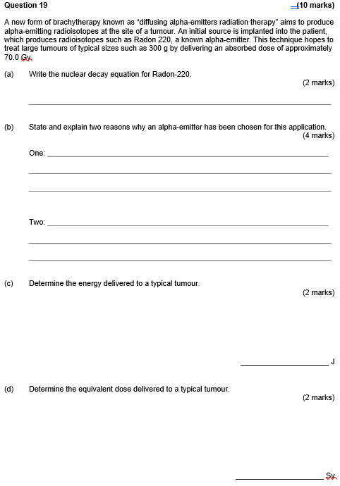

## 2015 Comprehension

## 2016 Comprehension

## 2020 Comprehension

**Question 18 (16 marks)**

**Fukushima Daiichi Accident**

From <https://www.world-nuclear.org/information-library/safety-and-security/safety-of-plants/fukushima-daiichi-accident.aspx>

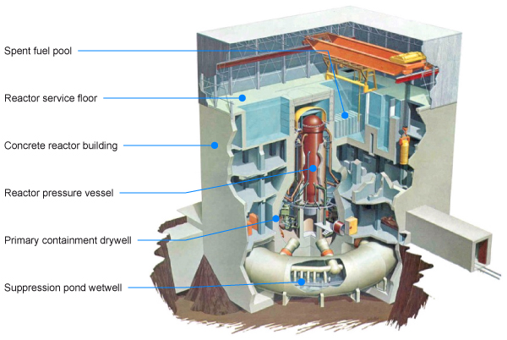

**Following a major earthquake, a 15-metre tsunami disabled the power supply and cooling of three Fukushima Daiichi reactors, causing a nuclear accident on 11 March 2011. All three cores largely melted in the first three days.** **Four reactors were written off due to damage in the accident.**

**Radioactive releases to air (following the accident)**

The most abundant radionuclide released into the air from among the many kinds of fission products in the fuel was volatile iodine-131 (a beta-emitter), which has a half-life of 8 days. The other main radionuclide is caesium-137 (a beta- and gamma-emitter), which has a 30-year half-life, is easily carried in a plume, and when it lands it may contaminate land for some time.

When assessing the significance of atmospheric releases of radioactive materials, the activity levels due to the Cs-137 are multiplied by 40 and added to the activity due to I-131 to give an "iodine-131 equivalent" figure.

Japan’s regulator, the Nuclear & Industrial Safety Agency (NISA), estimated in June 2011 that 770 PBq (iodine-131 equivalent) of radioactivity had been released, but the Nuclear Safety Commission (NSC, a policy body) in August lowered this estimate to 570 PBq**.**

**Radiation exposure on the plant site**

By the end of 2011, Tepco had checked the radiation exposure of 19,594 people who had worked on the site since 11 March. For many of these both external dose and internal doses (measured with whole-body counters) were considered. It reported that 167 workers had received doses over 100 mSv. Of these 135 had received 100 to 150 mSv, 23 150-200 mSv, three more 200-250 mSv, and six had received over 250 mSv (309 to 678 mSv) apparently due to inhaling iodine-131 fume early on.

The latter included the two unit 3-4 control room operators in the first two days who had not been wearing breathing apparatus. There were up to 200 workers on site each day. Recovery workers are wearing personal monitors, with breathing apparatus and protective clothing which protect against alpha and beta radiation.

So far over 3500 of some 3700 workers at the damaged Daiichi plant have received internal check-ups for radiation exposure, giving whole body count estimates. The level of 250 mSv was the allowable maximum short-term dose for Fukushima Daiichi accident clean-up workers through to December 2011, 500 mSv is the international allowable short-term dose "for emergency workers taking life-saving actions". Since January 2012, the allowable maximum has reverted to 50 mSv/yr.

1. Part of the design at the Fukushima Daiichi reactors were cooling ponds for spent fuel rods from the reactor core. Describe the composition of the spent fuel rods and why they need to be cooled in this way for some time.

(2 marks)

1. Inevitably, radioisotopes from the reactor cores escaped into the environment. One of these was the beta-emitter caesium-137. Write a balanced nuclear equation for this beta-decay.

(2 marks)

1. Using the information provided in the article, calculate the percentage of an Iodine-131 sample after a time-period of 30 days.

(4 marks)

1. The unit ‘PBq’ stands for the ‘peta-becquerel’. The prefix ‘peta’ is equal to 1015. The estimated I-131 equivalent amount of radiation released by the Fukishima accident was 570PBq. Calculate the number of radiation emissions this would represent in one (1) minute.

(2 marks)

1. The allowable maximum short-term dose for Fukushima Daiichi accident clean-up workers in the short period after the accident was 250 mSv.
2. Calculate the absorbed dose (in Grays) this would represent if the radiation emitted is exclusively alpha radiation.

(2 marks)

1. Calculate the quantity of ionising radiation absorbed by a 65 kg worker who receives the dose equivalent described in part (i). Assume a full body exposure.

(2 marks)

1. The emergency workers who wore protective clothing were protected from some forms of radiation, but still received radiation doses up to 250 mSv. Explain.

(2 marks)

# Nuclear Fission – 4.1

## 2018

## 2019

# Nuclear Reactors 4.2

## 2021

**Question 15 (16 marks)**

A **fast** **breeder reactor** - unlike other ‘conventional’ reactors - is a nuclear fission reactor that generates more fissile material than it consumes. Breeder reactors achieve this by irradiation of a ‘fertile material’ (ie – a radioisotope that can be turned into a fissile material by capturing bombarding neutrons). An example of a ‘fertile material’ is uranium-238 and this is loaded into the reactor along with fissile fuel (eg – U-235). Modern nuclear weapons adopt the same ‘fast- breeding’ principle.

The extra fissile material that is produced by irradiation of U-238 with neutrons is an isotope of Plutonium, Pu-239. The initial neutron bombardment of U-238 produces U-239. This radioisotope of Uranium is a beta emitter and transmutes into fissile Pu-239. The extra fissile

Neutron capture in a nuclear reactor or weapon can only occur with slow-moving neutrons.

1. Name the feature within a nuclear fission reactor that is responsible for reducing the speed of fast-moving neutrons. Explain how this material works.

(3 marks)

___________________________________________________________________________________________________________________________________________________________________________________________________________________________________________________________________________________________________________________________________________________________________________________________________________

The chain reaction that occurs in the fast breeder reactor is a ‘controlled’ chain reaction. This contrasts with the ‘uncontrolled’ chain reaction which occurs when a nuclear weapon is detonated.

b) (i) Name the structure in the nuclear fission reactor that is responsible for ‘controlling’ the chain reaction. Explain how this structure achieves this.

(3 marks)

__________________________________________________________________________________________________________________________________________________________________________________________________________________________________________________________________________________________________________________________________________________________________________________________________________________________________________________________________________________________

(ii) Explain why the chain reaction in a nuclear reactor must be ‘controlled’ – but is **not** ‘controlled’ in the same way in a nuclear weapon.

(3 marks)

________________________________________________________________________________________________________________________________________________________________________________________________________________________________________________________________________________________________________________________________________________________________________________________________________________________________________________

In a nuclear bomb, prior to detonation, two sub-critical samples of the fissile material are separated at either end of a long tube inside the bomb (see below).

The bomb is carried on a long-range missile and is detonated at a high altitude above the target. Upon detonation, conventional explosives force the two sub-critical samples together and a massive explosion results.

c) Define the terms ‘critical mass’ and ‘sub-critical mass’ and use them to explain the operation of the nuclear bomb.

(4 marks)

____________________________________________________________________________________________________________________________________________________________________________________________________________________________________________________________________________________________________________________________________________________________________

d) In the introduction to this question, a comparison was made between fast breeder reactors and ‘conventional’ reactors. Briefly explain how a fast breeder reactor increases the overall power output of a fission reactor compared to that produced by other ‘conventional’ reactors.

(3 marks)

________________________________________________________________________________________________________________________________________________________________________________________________________________________________________________________________________________________________________________________________________________________________________________________________________________________________________________________________________________________________________________________________________________________________________________________________________________________________________________________________________________________________________________________________________

# Nuclear Fusion and Binding Energy 4.3

## 2015

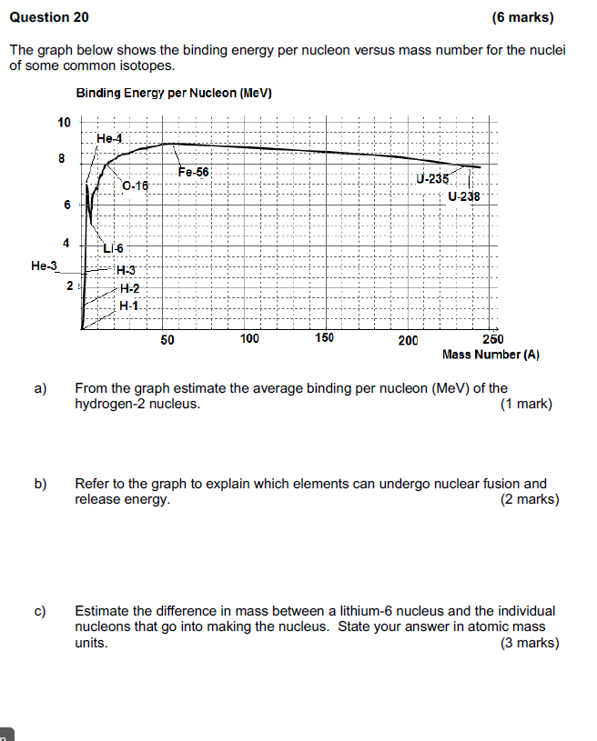

## 2016

## 2017

## 2020

## 2020

## 2021

## 2021

## 2019 Comprehension

## 2022

